Emu 1 and Emu 2 – Share a video | **Teams Meeting** |

**Step 1**

From the Emu 1 room console – Look up the name or email of whoever wants to share content and hit “Call” on the top right screen of the Emu room console.



**Step 2**

Accept the Teams call from the contacted person’s laptop. They should now be in a Teams call with [Emu1.room@anglicare.org](mailto:Emu1.room@anglicare.org)

**Step 3**

Share/ Reshare your screen by clicking “Share” button on the top right of the laptop screen and make sure to tick the “Include Sound” option found in the top right of the screen.



**Troubleshooting**

* **Where to find the Emu 1 Room Console?**

Entrance Door by the Ground Floor Kitchenette

* **Audio Issues? I gotchu** 😊

Stop sharing the screen and Refer to Step 3.

* **Still No Audio?**

Check your laptop’s volume and/or the video’s volume itself if it’s up.

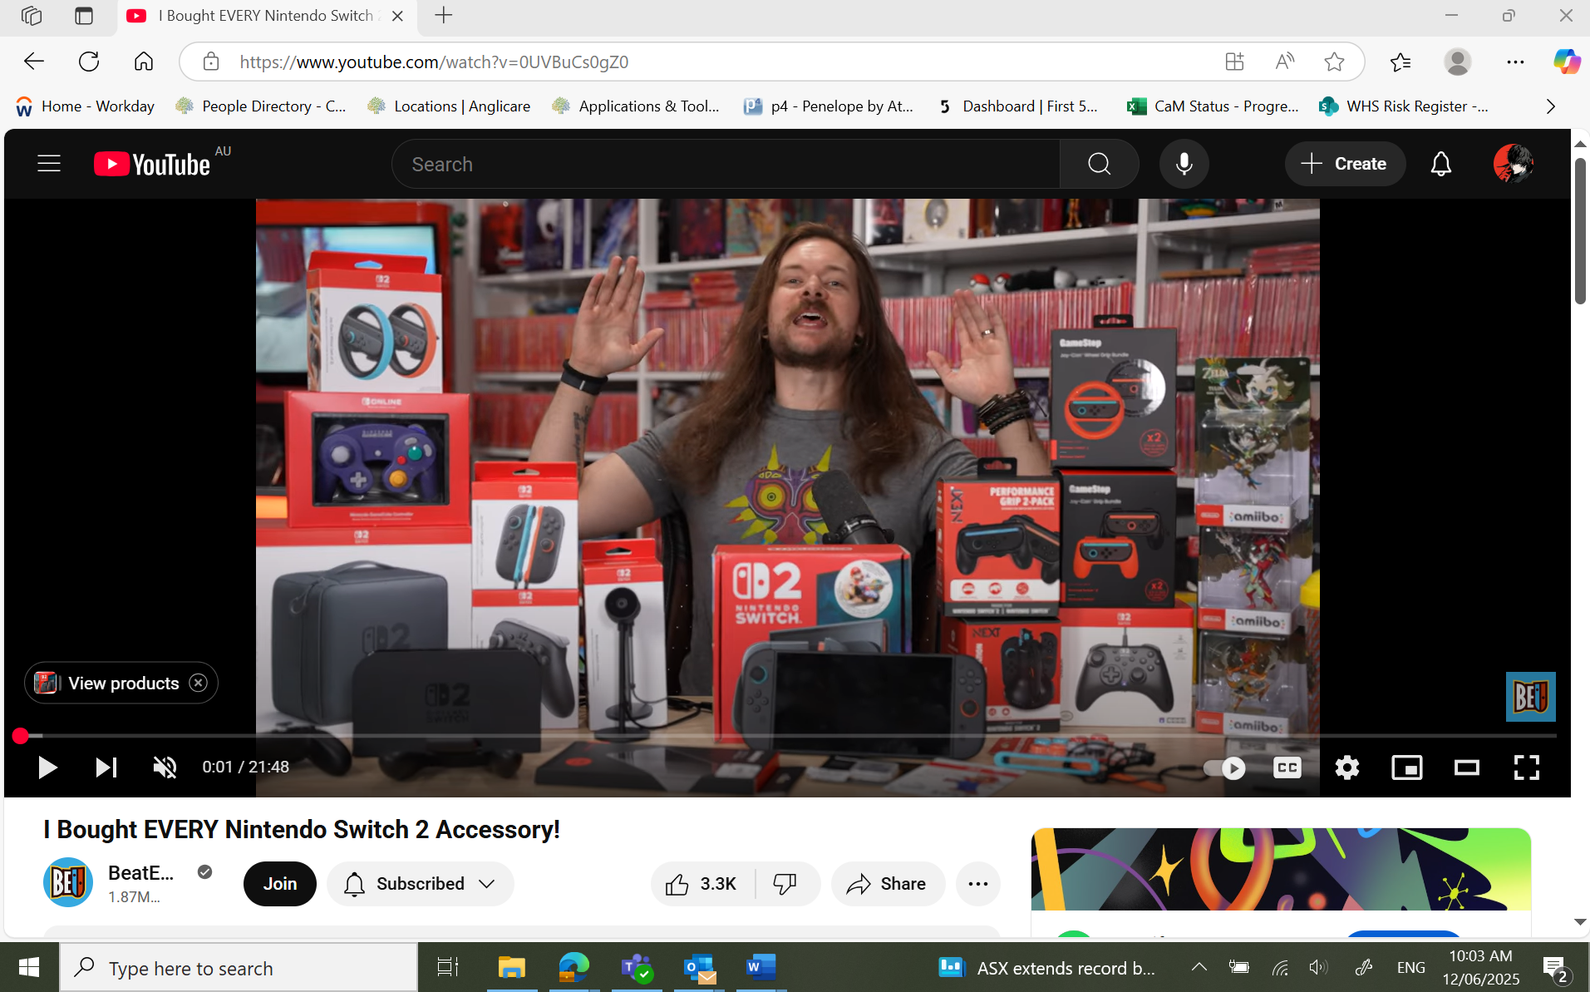



* **Audio Feedback Loop – Mute It!**

Mute your microphone from Teams.

